Reflection Activity – Team #2

Members: Harris Borrawski, Craig Cabrey, Kocsen Chung, Richard Sparraza

* Compile times:
  + Estimated: (80 + 225 + 100 + 140)/4 = 136
  + Actual: 150
  + 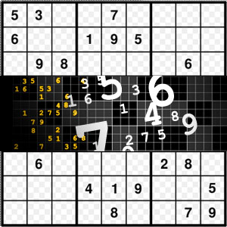Final Ratio(Actual/Estimate) :
* Reflection
  + What went well
    - Never segfault/got out of bounds
    - Tests would pass smoothly
    - It was fun
    - Great use of make files
    - Didn’t have to do the engine
  + What can we improve
    - Depend on compiler to find issues
    - Documenting
    - Working in order described
    - Modifying .doc file from bash (couldn’t do)